

Capstone Project Report
Report 3 – Software Requirement Specification

– Ho Chi Minh, December 2024 –
Table of Contents
I. Record of Changes 3
II. Software Requirement Specification 4
1. Product Overview 4
2. User Requirements 4
2.1 Actors 4
2.2 Use Cases 5
3. Functional Requirements 10
3.1 System Functional Overview 10
3.2 Guest Feature 18
3.3 Registered User Feature 21
3.4 Customer Feature 23
3.5 Business Feature 24
3.6 Admin Feature 30
4. Non-Functional Requirements 34
4.1 External Interfaces 34
4.2 Quality Attributes 34
5. Requirement Appendix 34
5.1 Business Rules 34
5.2 Application Messages List 36

I. Record of Changes
Date | A*  M, D | In charge | Change Description
16/10/2024 | A | NgocPD | Add Product Overview.
17/10/2024 | A | ThaoHTP | Add User Requirements, Non-Functional Requirements
18/10/2024 | A | QuocLNH | Add Functional Requirements, Requirement Appendix.
30/11/2024 | M | QuocLNH | Update Context Diagram, User Requirements, Functional Requirements.
12/12/2024 | M | QuocLNH,  HieuNM | Update Functional Requirements.
12/12/2024 | M | QuocLNH,  HieuNM | Update Requirement Appendix.
*A - Added M - Modified D - Deleted

II. Software Requirement Specification

1. Product Overview
The shoe cleaning service platform is a system that connects consumers and businesses that provide shoe care and cleaning services. Providing cleaning services based on the needs of customers is made simple with an easy-to-use ordering system. Service providers can become suppliers on the system and promote their services online by purchasing packages.
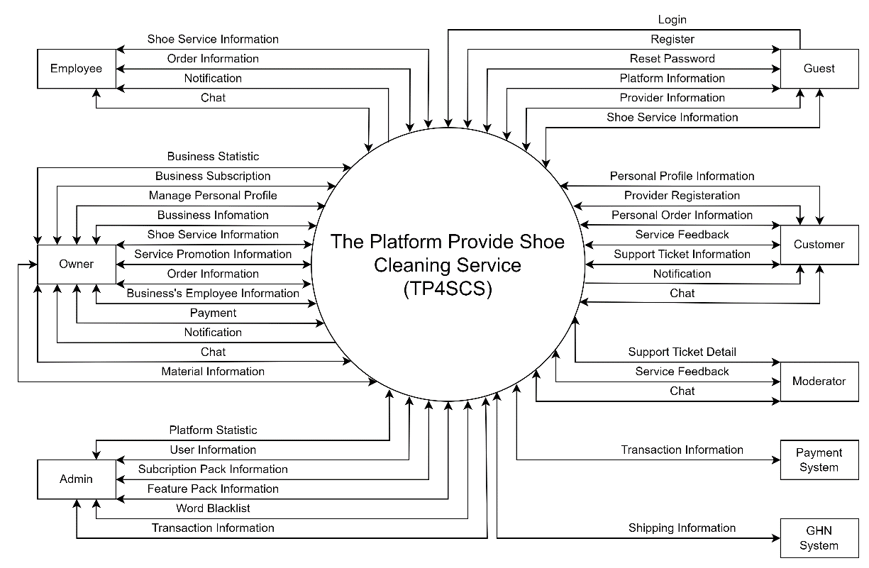

2. User Requirements

2.1 Actors
# | Actor | Description
01 | Admin | The administrator is responsible for managing the system related to managing accounts in the system including the accounts of: Moderator, Shop Owner, Employee, Customer. As well as managing ranking, subscription and transaction.
02 | Moderator | Moderator is responsible for managing and resolving complaints from Shop Owners and Customers.
03 | Owner | Owners can manage their business information, view and manage employee information, manage services and promotions.
04 | Employee | A business's employee is authorized to track and process orders, as well as advise customers.
05 | Customer | Customers are people who use the functions on the platform such as: Becoming a shop owner, managing personal information, managing shopping carts and orders, receiving notifications from the platform as well as managing feedback and support ticket.
06 | Guest | Guest are are customers who can visit the application without login.

2.2 Use Cases

2.2.1 Diagram(s)
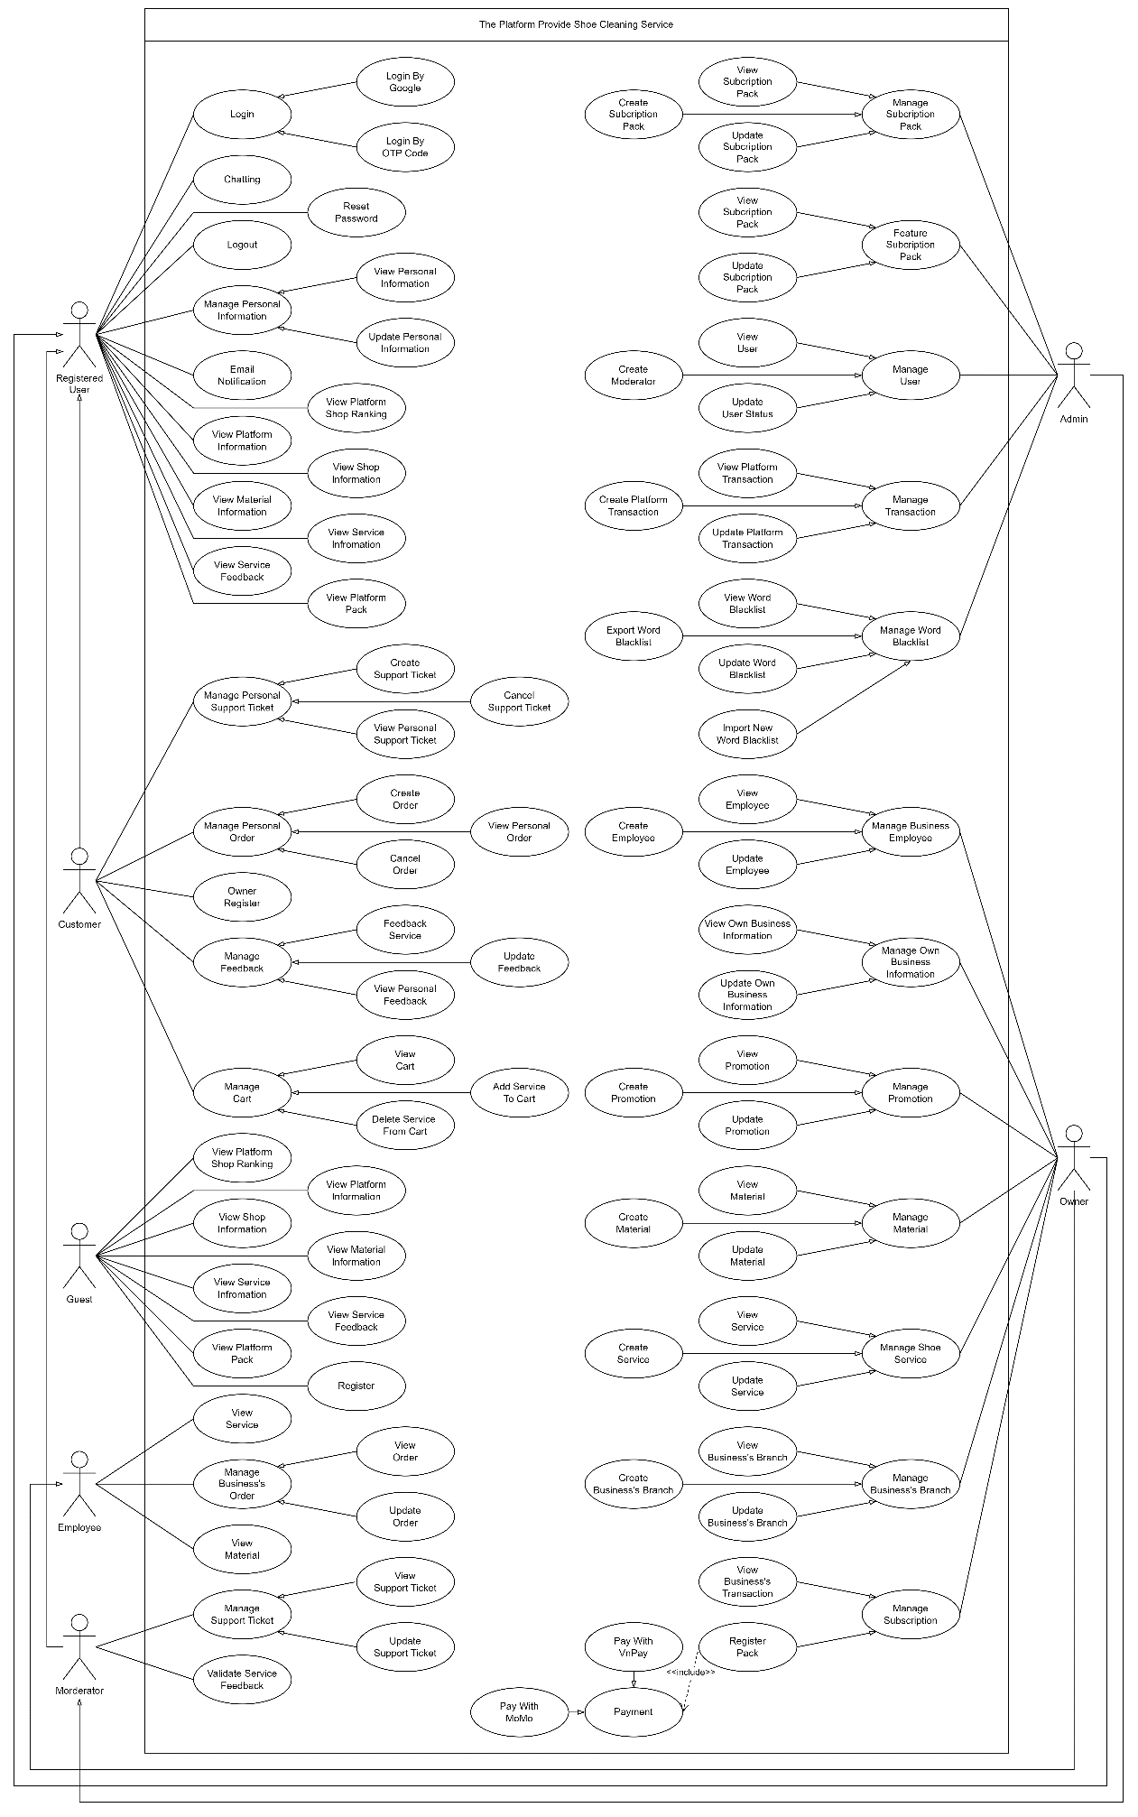

2.2.2 Descriptions

2.2.2.1 Guest:
# | Use Case | Actors | Use Case Description
01 | Register | Guest | Register a customer or owner account to login to system
02 | View Platform Shop Ranking | Guest | View platform’s top 10 performance of business by month
03 | View Shop Information | Guest | View shop profile information of the platform
04 | View Service Information | Guest | View service information of the platform
05 | View Material Information | Guest | View service list of material information
06 | View Service Feedback | Guest | View service’s feedback information of the platform
07 | View Platform Pack | Guest | View platform subscription pack and feature information
08 | View Platform Information | Guest | View the specific information of the platform

2.2.2.2 Customer:
# | Use Case | Actors | Use Case Description
01 | View Personal Support Ticket | Customer | View account sent support ticket information
02 | Create Support Ticket | Customer | Create new support ticket
03 | Cancel Support ticket | Customer | Cancel pending support ticket
04 | View Personal Order | Customer | View account service order information
05 | Create Order | Customer | Create service order
06 | Cancel Order | Customer | Cancel pending service order
07 | Owner Register | Customer | Register to become business’s owner in the platform
08 | View Personal Feedback | Customer | View sent service feedback information
09 | Feedback Service | Customer | Create new ordered service feedback
10 | Update Feedback | Customer | Update sent service feedback
11 | View Cart | Customer | View personal cart information
12 | Add To Cart | Customer | Add more service to personal cart
13 | Delete To Cart | Customer | Remove service from personal cart

2.2.2.3 Registered User:
# | Use Case | Actors | Use Case Description
01 | Login | Customer,  Owner,  Employee,  Moderator,  Admin | Login to the system with registered account
02 | Login By Google | Customer,  Owner,  Employee,  Moderator,  Admin | Login to the system with Google account
03 | Login By OTP Code | Customer,  Owner,  Employee,  Moderator,  Admin | Login to the system with OTP code
04 | Logout | Customer,  Owner,  Employee,  Moderator,  Admin | Logout the platform
05 | Reset Password | Customer,  Owner,  Employee,  Moderator,  Admin | Reset password without login by sending reset link through email
06 | View Personal Information | Customer,  Owner,  Employee,  Moderator,  Admin | View account profile information
07 | Update Personal Information | Customer,  Owner,  Employee,  Moderator,  Admin | Update account profile information
08 | Chatting | Customer,  Owner,  Employee,  Moderator,  Admin | Chatting with others using platform chat system
09 | Email Notification | Customer,  Owner,  Employee,  Moderator,  Admin | Send platform notification through email

2.2.2.4 Owner:
# | Use Case | Actors | Use Case Description
01 | View Own Business Information | Owner | View own information of registered business
02 | Update Own Business Information | Owner | Update own information of registered business
03 | View Promotion | Owner | View service’s promotion information
04 | Create Promotion | Owner | Create service’s promotion
05 | Update Promotion | Owner | Update service’s promotion information
06 | View Material | Owner | View service’s material information
07 | Create Material | Owner | Create new service material
08 | Update Material | Owner | Update service’s material information
09 | View Service | Owner | View business’s service information
10 | Create Service | Owner | Create new service for business
11 | Update Service | Owner | Update business’s service information
12 | View Business’s Branch | Owner | View business’s branch information
13 | Create Business Branch | Owner | Create new branch for business
14 | Update Business Branch | Owner | Update business’s branch information
15 | View Business’s Employee | Owner | View business’s employee information
16 | Create Business Employee | Owner | Create new employee for business
17 | Update Business Employee | Owner | Update business’s employee information
18 | View Business’s Transaction | Owner | View processed business’s transaction information
19 | Register Pack | Owner | Register a subscription pack or feature pack in the platform
20 | Pay With VnPay | Owner | Process payment using VnPay
21 | Pay With MoMo | Owner | Process payment using MoMo

2.2.2.5 Employee:
# | Use Case | Actors | Use Case Description
01 | View Service | Employee | View branch’s available service information
02 | View Material | Employee | View service’s available material information
03 | View Order | Employee | View branch’s order information
04 | Update Order | Employee | Update branch’s order information

2.2.2.6 Moderator:
# | Use Case | Actors | Use Case Description
01 | View Support Ticket | Moderator | View platform’s sent support ticket information
02 | Update Support Ticket | Moderator | Update support ticket information
03 | Validate Service Feedback | Moderator | Validate content and asset of service feedback

2.2.2.7 Admin:
# | Use Case | Actors | Use Case Description
01 | View Subscription Pack | Admin | View platform’s subscription pack information
02 | Create Subscription Pack | Admin | Create new subscription pack
03 | Update Subscription Pack | Admin | Update platform’s subscription pack information
04 | View Feature Pack | Admin | View platform’s feature pack information
05 | Update Feature Pack | Admin | Update platform’s feature pack information
06 | View User | Admin | View platform’s user account information
07 | Create Moderator | Admin | Create new moderator account for platform
08 | Update User Status | Admin | Update platform’s user account status
09 | View Platform’s Transaction | Admin | View platform’s transaction information
10 | Create Platform’s Transaction | Admin | Create new transaction
11 | Update Platform’s Transaction | Admin | Update platform’s transaction information
12 | View Word Blacklist | Admin | View platform’s word blacklist
13 | Export Word Blacklist | Admin | Export word blacklist to excel file
14 | Update Word Blacklist | Admin | Update platform’s word blacklist
15 | Import New Word Blacklist | Admin | Import new word blacklist to the platform

3. Functional Requirements

3.1 System Functional Overview

3.1.1 Screen Flow

3.1.1.1 Guest Screen Flow
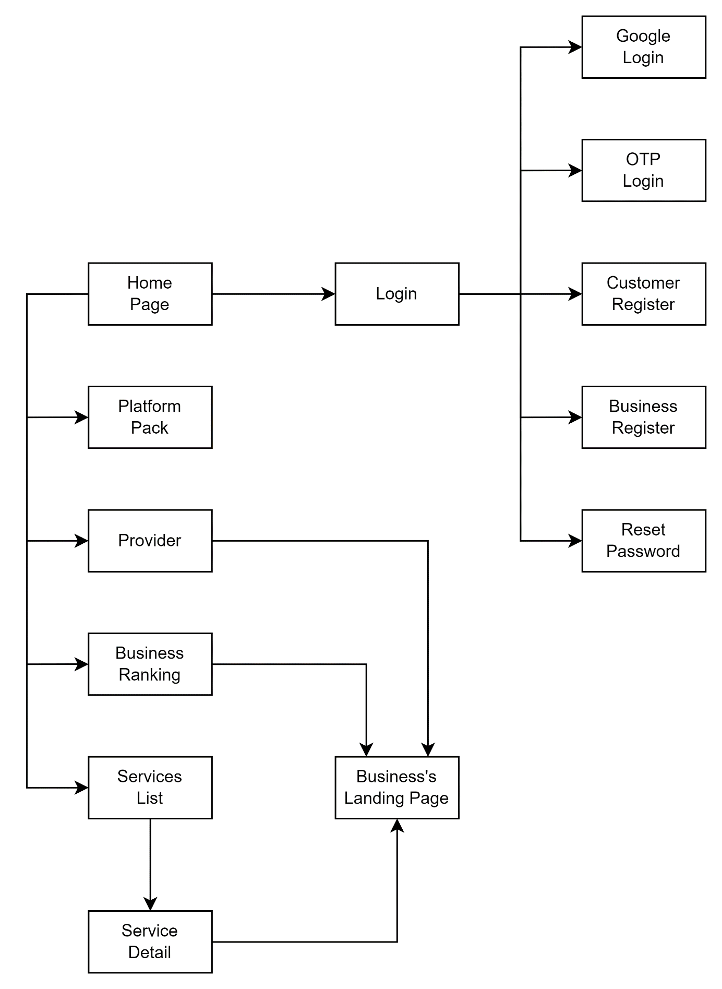

3.1.1.2 Admin Screen Flow
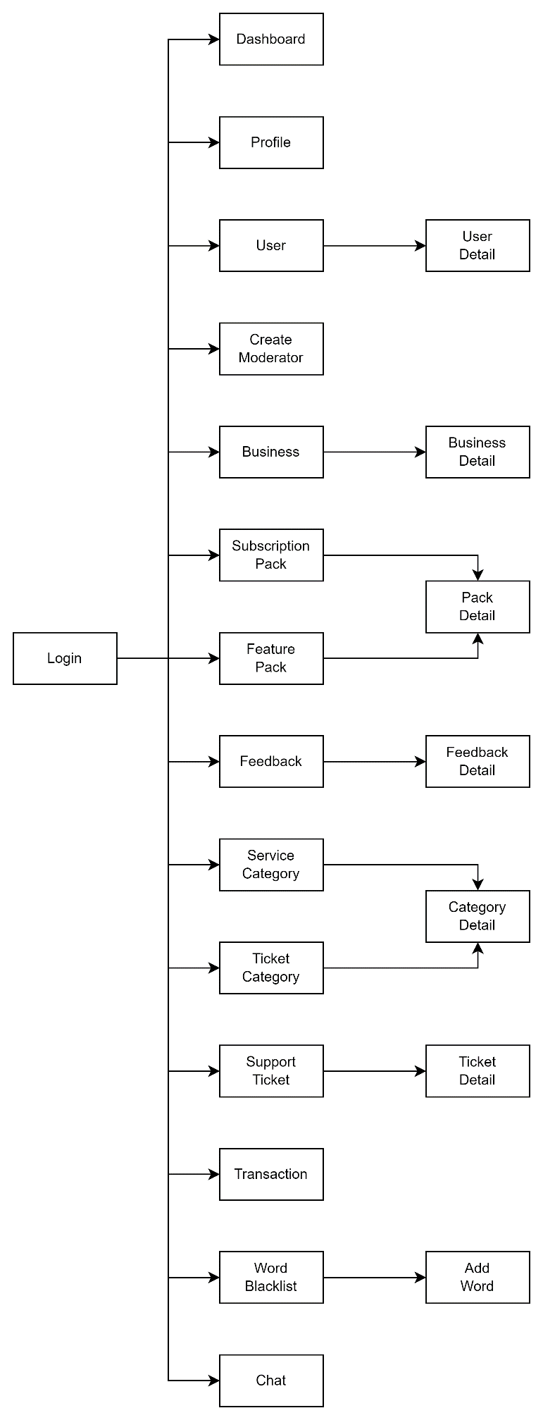

3.1.1.3 Business Screen Flow
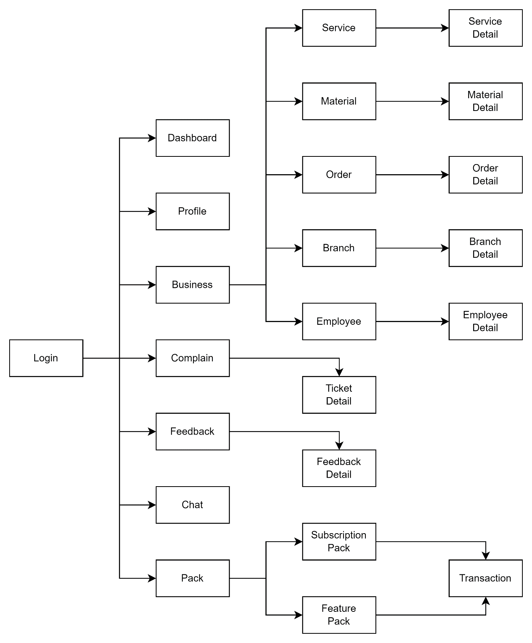

3.1.1.4 Customer Screen Flow
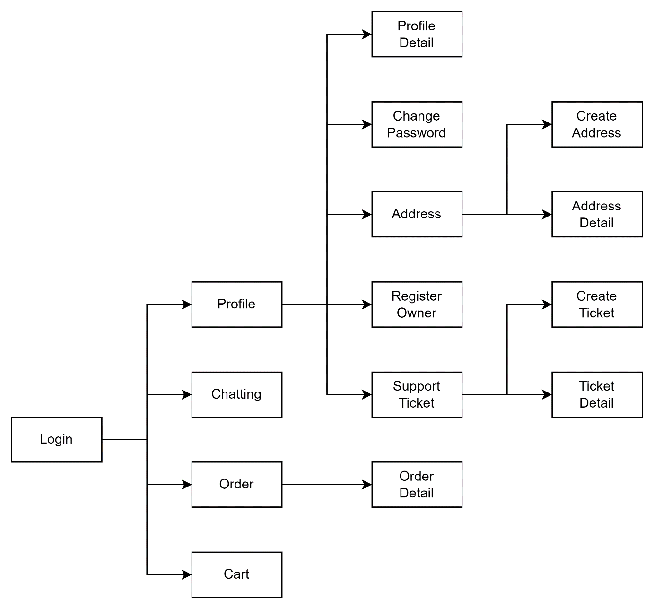

3.1.2 Screen Authorization
Screen | Guest | Customer | Owner | Employee | Moderator | Admin
Home Page | X | X | X | X | X | X
Platform Pack | X | X | X | X | X | X
Provider | X | X | X | X | X | X
Business Ranking | X | X | X | X | X | X
Business’s Landing Page | X | X | X | X | X | X
Service List | X | X | X | X | X | X
Service Detail | X | X | X | X | X | X
Customer Register | X
Business Register | X
Login |  | X | X | X | X | X
Google Login |  | X | X | X | X | X
OTP Login |  | X | X | X | X | X
Reset Password |  | X | X | X | X | X
Profile |  | X | X | X | X | X
Profile Detail |  | X | X | X | X | X
Change Password |  | X | X | X | X | X
Support Ticket |  | X | X | X | X | X
Create Ticket |  | X | X | X
Ticket Detail |  | X | X | X | X | X
Address |  | X
Create Address |  | X
Address Detail |  | X
Owner Register |  | X
Chat |  | X | X | X | X | X
Order |  | X | X | X | X | X
Order Detail |  | X | X | X | X | X
Cart |  | X
Cart Detail |  | X
Dashboard |  |  | X |  |  | X
Business |  |  | X |  |  | X
Service |  |  | X | X
Material |  |  | X | X
Material Detail |  |  | X | X
Branch |  |  | X
Branch Detail |  |  | X
Employee |  |  | X
Employee Detail |  |  | X
Complain |  |  | X |  | X | X
Feedback |  |  | X |  | X | X
Feedback Detail |  |  | X |  | X | X
Pack |  |  | X |  |  | X
Subscription Pack |  |  | X |  |  | X
Feature Pack |  |  | X |  |  | X
Transaction |  |  | X |  |  | X
User |  |  |  |  |  | X
User Detail |  |  |  |  |  | X
Create Moderator |  |  |  |  |  | X
Service Category |  |  |  |  |  | X
Ticket Category |  |  |  |  |  | X
Category Detail |  |  |  |  |  | X
Word Blacklist |  |  |  |  |  | X
Add Word |  |  |  |  |  | X

3.1.3 Non-Screen Function
# | Feature | System Function | Description
01 | Send Mail | Send Email | The system will send mail in the following case:  - Order Notification  - Ticket Notification  - Verify Email Link  - OTP Login Code  - Reset Password Link

3.1.4 Entity Relationship Diagram

3.1.2.1 Concept Model
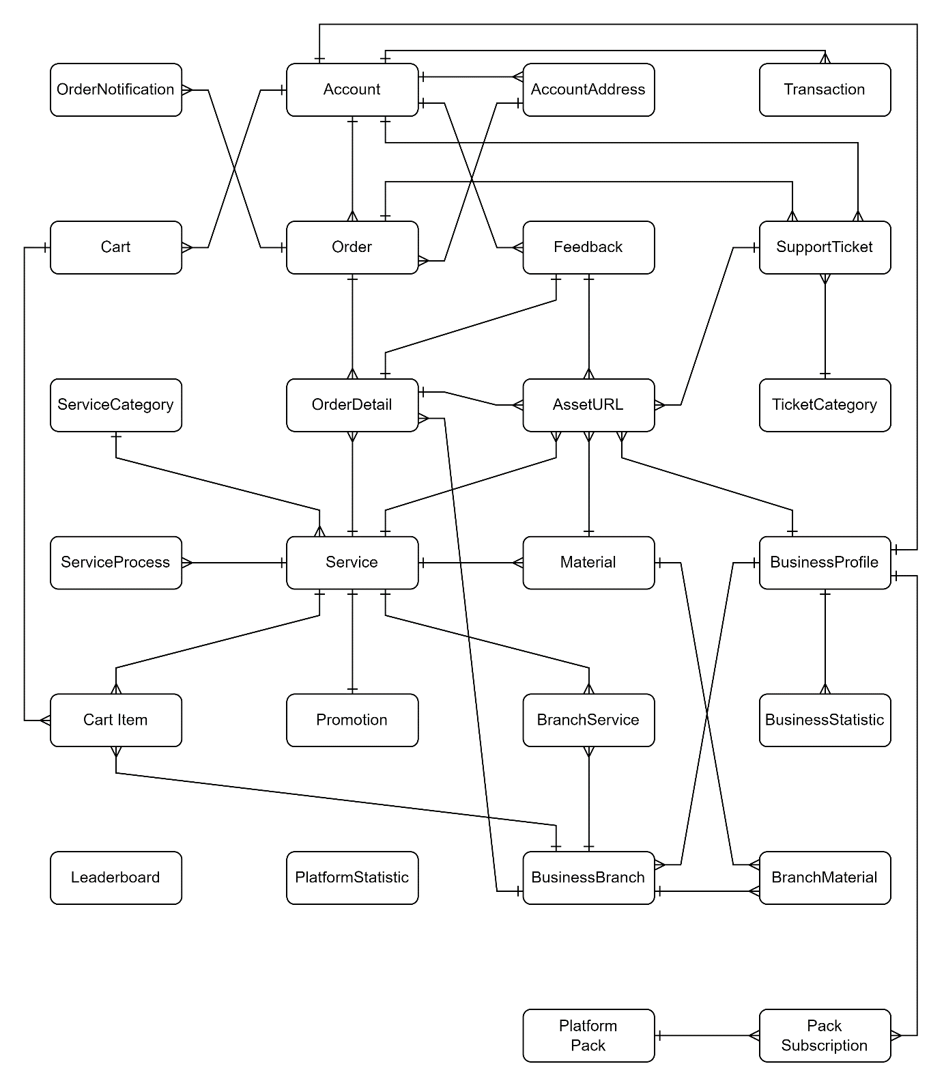

3.1.2.2 Logical Model
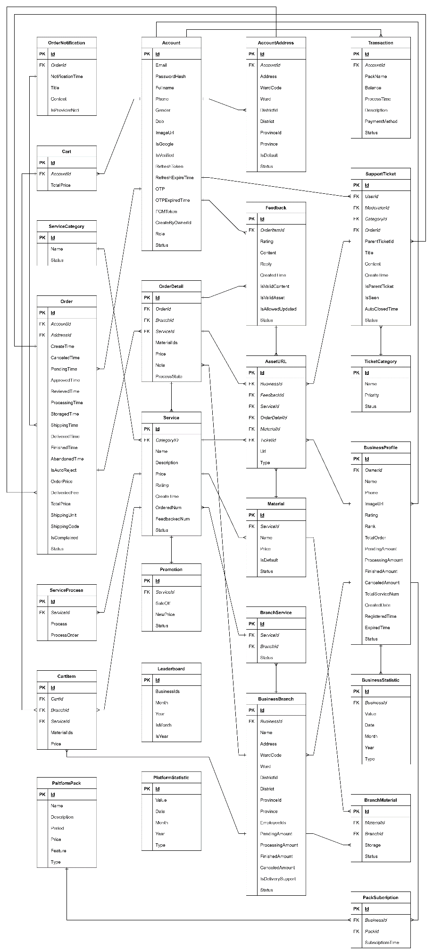

Entities Description
# | Entity | Description
01 | Account | Store user’s account information in platform
02 | AccountAddress | Store user’s address in platform
03 | AssetURL | Store image or video URL of BusinessProfile, Feedback and Service entities
04 | BranchMaterial | Store information of material has in branch
05 | BranchService | Store information of service has in branch
06 | BuisnessBranch | Store branch information of BusinessProfile entity
07 | BusinessProfile | Store business information in platform
08 | BusinessStatistic | Store business statistic information in platform
09 | Cart | Store account’s cart in platform
10 | CartItem | Store items have been added to Cart entity
11 | Feedback | Store service feedback of customer in platform
12 | Leaderboard | Store platform top 10 business ranking information
13 | Material | Store service require or addition material
14 | Order | Store order information in platform
15 | OrderDetail | Store order items of Order entity
16 | OrderNotification | Store order’s notification context in platform
17 | PackSubscription | Store business registered feature pack information
18 | PlatformPack | Store platform pack information: subscription pack and feature pack
19 | PlatformStatistic | Store platform statistic information
20 | Promotion | Store sale off information of Service entity
21 | Service | Store service information in platform
22 | ServiceCategory | Store category information of service in platform
23 | ServiceProcess | Store process information of service in platform
24 | SupportTicket | Store submitted support ticket information in platform
25 | TicketCategory | Store category information of support ticket in platform
26 | Transaction | Store transaction information in platform

3.2 Guest Feature
# | Actor | Function Name | Purpose | Data Requirements | Data  Validation | Business Rule
01 | Guest,  Customer,  Owner,  Moderator,  Admin | View Platform Pack | View all platform pack’s information | N/A | N/A
02 | Guest,  Customer,  Owner,  Moderator,  Admin | View Provider List | View platform business list | N/A | N/A
03 | Guest,  Customer,  Owner,  Moderator,  Admin | View Business Ranking | View platform top10 business by month | N/A | N/A
04 | Guest,  Customer,  Owner,  Moderator,  Admin | View Business Detail | View business detail information | Business Id | Business Id:  + Type: Text Field (int)
05 | Guest,  Customer,  Owner,  Moderator,  Admin | View Service List | View platform service list | N/A | N/A
06 | Guest,  Customer,  Owner,  Moderator,  Admin | View Service Detail | View service detail information | Service Id | Service Id:  + Type: Text Field (int)
07 | Customer,  Owner,  Moderator,  Admin | Login | Login to platform using system account | Email  Password | Email  + Type: Text Field (string)  + Max Length = 50  Password  + Type: Text Field (string)  + Min Length = 8  + Max Length = 16 | BR-03  BR-05  BR-06  BR-07  BR-08  BR-09
08 | Customer,  Owner,  Moderator,  Admin | Login By Google | Login to platform using Google account | N/A | N/A
09 | Customer,  Owner,  Moderator,  Admin | Login By OTP | Login to platform using OTP code | Email  OTP Code | Email  + Type: Text Field (string)  + Max Length = 50  OTP Code  + Type: Text Field (int)  + Min Length = 6  + Max Length = 6 | BR-03
10 | Guest | Customer Register | Register new customer account | Email  Phone  Full Name  Birth Day  Gender  Password  Confirm Password | Email  + Type: Text Field (string)  + Max Length = 50  Phone  + Type: Text Field (string)  + Min Length = 10  + Max Length = 10  Full Name  + Type: Text Field (string)  + Max Length = 50  Birth Day  + Type: Text Field (date)  Gender  + Type: Text Field (string)  Password  + Type: Text Field (string)  + Min Length = 8  + Max Length = 16  Confirm Password  + Type: Text Field (string)  + Min Length = 8  + Max Length = 16 | BR-02  BR-03  BR-04  BR-10
11 | Guest | Owner Register | Register new owner account and business profile | Email  Phone  Full Name  Birth Day  Gender  Password  Confirm Password  Business Name  Business Phone | Email  + Type: Text Field (string)  + Max Length = 50  Phone  + Type: Text Field (string)  + Min Length = 10  + Max Length = 10  Full Name  + Type: Text Field (string)  + Max Length = 50  Birth Day  + Type: Text Field (date)  Gender  + Type: Text Field (string)  Password  + Type: Text Field (string)  + Min Length = 8  + Max Length = 16  Confirm Password  + Type: Text Field (string)  + Min Length = 8  + Max Length = 16  Business Name  + Type: Text Field (string)  + Max Length = 50  Business Phone  + Type: Text Field (string)  + Min Length = 10  + Max Length = 10 | BR-02  BR-03  BR-04  BR-10
12 | Customer,  Owner,  Moderator,  Admin | Reset Password | Change password without login to the platform | Email  New Password  Confirm Password | Email  + Type: Text Field (string)  + Max Length = 50  New Password  + Type: Text Field (string)  + Min Length = 8  + Max Length = 16  Confirm Password  + Type: Text Field (string)  + Min Length = 8  + Max Length = 16 | BR-03

3.3 Registered User Feature
# | Actor | Function Name | Purpose | Data Requirements | Data  Validation | Business Rule
01 | Customer,  Owner,  Employee,  Moderator,  Admin | Logout | Delete authorization token from the system | N/A | N/A
02 | Customer,  Owner,  Employee,  Moderator,  Admin | View Profile Detail | View personal account detail information | Account Id | Account Id  + Type: Text Field (int)
03 | Customer,  Owner,  Employee,  Moderator,  Admin | Update Profile | Update personal account information | Account Id  Full Name  Gender  Birth Day | Account Id  + Type: Text Field (int)  Full Name  + Type: Text Field (string)  + Max Length = 50  Birth Day  + Type: Text Field (date)  Gender  + Type: Text Field (string) | BR-02  BR-04
04 | Customer,  Owner,  Employee,  Moderator,  Admin | Change Password | Change personal account password | Account Id  Old Password  New Password  Confirm Password | Account Id  + Type: Text Field (int)  Old Password  + Type: Text Field (string)  + Min Length = 8  + Max Length = 16  New Password  + Type: Text Field (string)  + Min Length = 8  + Max Length = 16  Confirm Password  + Type: Text Field (string)  + Min Length = 8  + Max Length = 16 | BR-05  BR-06  BR-07  BR-08  BR-09
05 | Customer,  Owner,  Employee,  Moderator,  Admin | Chat | Chat with other account of the system | Sender Id  Receiver Id  Content | Sender Id  + Type: Text Field (int)  Receiver Id  + Type: Text Field (int)  Content  + Type: Text Field (string)
 | Customer,  Owner,  Employee,  Moderator,  Admin | View Support Ticket Category | View category information of the support ticket | N/A | N/A
 | Customer,  Owner,  Employee | View Sent Support Ticket | View account sent support ticket | Account Id | Account Id  + Type: Text Field (int)
 | Customer,  Owner,  Employee,  Moderator,  Admin | View Support Ticket Detail | View support ticket detail | Ticket Id | Ticket Id  + Type: Text Field (int)
 | Customer,  Owner,  Employee | Create Support Ticket | Create new support ticket | Ticket Id  Title  Content  Asset | Ticket Id  + Type: Text Field (int)  Title  + Type: Text Field (string)  + max Length = 100  Content  + Type: Text Field (string)  Asset  + Type: Text Field (string)
 | Customer,  Owner,  Employee,  Moderator,  Admin | Update Support Ticket | Update new information of a support ticket | Ticket Id  Status | Ticket Id  + Type: Text Field (int)  Status  + Type: Text Field (string)

3.4 Customer Feature
# | Actor | Function Name | Purpose | Data Requirements | Data  Validation | Business Rule
01 | Customer | View Personal Address | View created address of the account | Account Id | Account Id  + Type: Text Field (int)
02 | Customer | View Address Detail | View address detail information | Address Id | Address Id  + Type: Text Field (int)
03 | Customer | Create New Address | Create new address to account | Account Id  Address  Ward  District  Province  Is Default | Account Id  + Type: Text Field (int)  Address  + Type: Text Field (string)  Ward  + Type: Text Field (string)  District  + Type: Text Field (string)  Province  + Type: Text Field (string)  Is Default  + Type: Text Field (bool)
04 | Customer | Update Address | Update address information | Account Id  Address  Ward  District  Province  Is Default | Account Id  + Type: Text Field (int)  Address  + Type: Text Field (string)  Ward  + Type: Text Field (string)  District  + Type: Text Field (string)  Province  + Type: Text Field (string)  Is Default  + Type: Text Field (bool)
05 | Customer | View Personal Order | View created order of the account | Account Id | Account Id  + Type: Text Field (int)
06 | Customer | View Order Detail | View order detail information | Order Id | Order Id  + Type: Text Field (int)
07 | Customer | Cancel Order | Cancel a booked order | Order Id | Order Id  + Type: Text Field (int)
08 | Customer | View Personal Cart | View account cart information | Account Id  Cart Id | Account Id  + Type: Text Field (int)  Cart Id  + Type: Text Field (int)
09 | Customer | Add To Cart | Add new service to account cart | Cart Id  Branch Id  Service Id  Material Ids | Cart Id  + Type: Text Field (int)  Branch Id  + Type: Text Field (int)  Service Id  + Type: Text Field (int)  Material Ids  + Type: Text Field (string)
10 | Customer | Remove From Cart | Remove added service from account cart | Cart Id  Cart Item Id | Cart Id  + Type: Text Field (int)  Cart Item Id  + Type: Text Field (int)
11 | Customer | Cart Checkout | Create a new order from cart | Cart Id | Cart Id  + Type: Text Field (int)

3.5 Business Feature
# | Actor | Function Name | Purpose | Data Requirements | Data  Validation | Business Rule
01 | Owner | View Dashboard | View business statistic information | Business Id | Business Id  + Type: Text Field (int)
02 | Owner | View Business’s Service | View business’s service list | Business Id | Business Id  + Type: Text Field (int)
03 | Owner,  Employee | View Branch’s Service | View branch’s service list | Branch Id | Branch Id  + Type: Text Field (int)
04 | Owner,  Employee | View Service Detail | View service detail information | Service Id | Service Id  + Type: Text Field (int)
05 | Owner | Create Service | Create new service | Service Information:  Branch Ids  Category Id  Name  Description  Price  Status  New Price  Asset URLs:  - Url  - Type  Service Processes  - Process  - Process Order  Business Id | Branch Ids  + Type: Array of integers (int[])  Price  Category Id  + Type: Text Field (int)  Name  + Type: Text Field (string)  Description  + Type: Text Field (string)  Price  + Type: Text Field (decimal)  + Min Value: 1  New Price  + Type: Text Field (decimal)  + Min Value: 1  +Constraint: New Price < Price  Status  + Type: Text Field (string)  Business Id  + Type: Text Field (int) | BR-04
06 | Owner | Update Service | Update service information | Service Information:  Branch Ids  Category Id  Name  Description  Price  Status  New Price  Asset URLs:  - Url  - Type  Service Processes  - Process  - Process Order  Business Id | Branch Ids  + Type: Array of integers (int[])  Price  Category Id  + Type: Text Field (int)  Name  + Type: Text Field (string)  Description  + Type: Text Field (string)  Price  + Type: Text Field (decimal)  + Min Value: 1  New Price  + Type: Text Field (decimal)  + Min Value: 1  +Constraint: New Price < Price  Status  + Type: Text Field (string)  Business Id  + Type: Text Field (int) | BR-04
07 | Owner | View Business’s Material | View business’s material list | Business Id | Business Id  + Type: Text Field (int)
08 | Owner,  Employee | View Branch’s Material | View branch’s material list | Branch Id | Branch Id  + Type: Text Field (int)
09 | Owner,  Employee | View Material Detail | View material detail information | Material Id | Material Id  + Type: Text Field (int)
10 | Owner | Create Material | Create new material | Material Information:  Branch Ids  Service Id  Name  Price  Status  Asset URLs:  - Url  - Type  Business Id | Branch Ids  + Type: Array of integers (int[])  Price  Service Id  + Type: Text Field (int)  Name  + Type: Text Field (string)  Price  + Type: Text Field (decimal)  + Min Value: 1  Price  Status  + Type: Text Field (string)  Business Id  + Type: Text Field (int) | BR-04
11 | Owner | Update Material | Update material information | Material Information:  Branch Ids  Service Id  Name  Price  Status  Asset URLs:  - Url  - Type  Business Id | Branch Ids  + Type: Array of integers (int[])  Price  Service Id  + Type: Text Field (int)  Name  + Type: Text Field (string)  Price  + Type: Text Field (decimal)  + Min Value: 1  Price  Status  + Type: Text Field (string)  Business Id  + Type: Text Field (int) | BR-04
12 | Owner,  Employee | View Branch’s Order | View branch’s order list | Branch Id | Branch Id  + Type: Text Field (int)
13 | Owner,  Employee | View Order Detail | View order detail information | Order Id | Order Id  + Type: Text Field (int)
14 | Owner,  Employee | Process Order | Update order process information | Order Id  Status  Is Ship  Delivery Fee  Pending Time  Approved Time  Received Time  Processing Time  Storage Time  ShippingTime  Delivered Time  Finished Time  Abandoned Time | Order Id  + Type: Text Field (int)  Status  + Type: Text Field (string)  Is Ship  Status  + Type: Text Field (bool)  Delivery Fee  + Type: Text Field (decimal)  + Min Value: 0
15 | Owner | View Business’s Branch | View business’s branch list | Business Id | Business Id  + Type: Text Field (int)
16 | Owner | View Branch Detail | View branch detail information | Branch Id | Branch Id  + Type: Text Field (int)
17 | Owner | Create Branch | Create new branch | Business Id  Name  Address  Ward Code  District Id  Province Id | Business Id  + Type: Text Field (int)  Name  + Type: Text Field (string)  Address  + Type: Text Field (string)  Ward Code  + Type: Text Field (string)  District Id  + Type: Text Field (int)  Province Id  + Type: Text Field (int) | BR-04
18 | Owner | Update Branch | Update branch information | Business Id  Name  Address  Ward Code  District Id  Province Id  Status | Business Id  + Type: Text Field (int)  Name  + Type: Text Field (string)  Address  + Type: Text Field (string)  Ward Code  + Type: Text Field (string)  District Id  + Type: Text Field (int)  Province Id  + Type: Text Field (int)  Status  + Type: Text Field (string)
19 | Owner | View Business’s Employee | View business’s employee list | Business Id | Business Id  + Type: Text Field (int)
20 | Owner | View Employee Detail | View employee detail information | Account Id | Account Id  + Type: Text Field (int)
21 | Owner | Create Employee | Create new employee | Owner Id  Email  Full Name  Phone  Gender  Dob  Branch Id | Owner Id  + Type: Text Field (int)  Email  + Type: Text Field (string)  + Max Length = 50  Full Name  + Type: Text Field (string)  + Max Length = 50  Phone  + Type: Text Field (string)  + Min Length = 10  + Max Length = 10  Gender  + Type: Text Field (string)  Branch Id  + Type: Text Field (int)  Dob  + Type: Text Field (Datetime) | BR-02  BR-03  BR-04  BR-10
22 | Owner | Update Employee | Update employee information | Account Id  Full Name  Dob | Account Id  + Type: Text Field (int)  Dob  + Type: Text Field (Datetime)  Full Name  + Type: Text Field (string)  + Max Length = 50
23 | Owner | Delete Employee | Delete employee from business | Account Id | Account Id  + Type: Text Field (int)
24 | Owner,  Employee | View Service Feedback | View order feedback information | Feedback Id | Feedback Id  + Type: Text Field (int)
25 | Owner,  Employee | Reply Feedback | Reply to order feedback | Feedback Id | Feedback Id  + Type: Text Field (int)
26 | Owner | VnPay Payment | Process payment using VnPay | Business Id  Pack Id | Business Id  + Type: Text Field (int)  Pack Id  + Type: Text Field (int)
27 | Owner | MoMo Payment | Process payment using MoMo | Business Id  Pack Id | Business Id  + Type: Text Field (int)  Pack Id  + Type: Text Field (int)
28 | Owner | View Business’s Pack Subscription | View business’s registered feature pack | Business Id | Business Id  + Type: Text Field (int)
29 | Owner | View Business’s Transaction | View business transaction | Business Id | Business Id  + Type: Text Field (int)

3.6 Admin Feature
# | Actor | Function Name | Purpose | Data Requirements | Data  Validation | Business Rule
01 | Admin | Platform Dashboard | View platform statistic information | N/A | N/A
02 | Admin | View Users | View system user list | N/A | N/A
03 | Admin | View User Detail | View user detail information | Account Id | Account Id  + Type: Text Field (int)
04 | Admin | Update User Status | Update system user status | Account Id  Status | Account Id  + Type: Text Field (int)  Status  + Type: Text Field (string)
05 | Admin | Create Moderator | Create new moderator to system | Email  Full Name  Phone  Gender  Birth Day | Email  + Type: Text Field (string)  + Max Length = 50  Phone  + Type: Text Field (string)  + Min Length = 10  + Max Length = 10  Full Name  + Type: Text Field (string)  + Max Length = 50  Birth Day  + Type: Text Field (date)  Gender  + Type: Text Field (string) | BR-02  BR-03  BR-04  BR-10
06 | Admin | View Businesses | View platform’s businesses list | N/A | N/A
07 | Admin | View Business Detail | View business profile information | Business Id | Account Id  + Type: Text Field (int)
08 | Admin | Update Business Status | Update platform’s business status | Business Id  Status | Business Id  + Type: Text Field (int)  Status  + Type: Text Field (string)
09 | Admin | Update Pack | Update platform’s pack information | Pack Id  Name  Period  Price | Pack Id  + Type: Text Field (int)  name  + Type: Text Field (string)  + Max Length = 50  Period  + Type: Text Field (int)  + Min Value = 1  + Max Value = 12  Price  + Type: Text Field (decimal) | BR-04
10 | Admin,  Moderator | View Feedbacks | View feedbacks list | N/A | N/A
11 | Admin,  Moderator | View Feedback Detail | View feedback detail | Feedback Id | Feedback Id  + Type: Text Field (int)
12 | Admin,  Moderator | Validate Feedback | Validate feedback content and assets | Feedback Id  Is Valid Content  Is Valid Asset | Feedback Id  + Type: Text Field (int)  Is Valid Content  + Type: Text Field (bool)  Is Valid Asset + Type: Text Field (bool)
13 | Admin | View Categories | View service, ticket category list | N/A | N/A
14 | Admin | View Categories Detail | View category detail | Category Id | Category Id  + Type: Text Field (int)
15 | Admin | Update Service Category | Update service category detail | Category Id  Name  Status | Category Id  + Type: Text Field (int)  Name  + Type: Text Field (string)  + Max Length = 50  Status  + Type: Text Field (string) | BR-04
16 | Admin | Update Ticket Category | Update ticket category detail | Category Id  Name  Priority  Status | Category Id  + Type: Text Field (int)  Name  + Type: Text Field (string)  + Max Length = 50  Priority  + Type: Text Field (int)  + Min Value = 1  + Max Value = 5  Status  + Type: Text Field (string)
17 | Admin,  Moderator | View Support Tickets | View support ticket list | N/A | N/A
18 | Admin,  Moderator | View Support Ticket Detail | View ticket detail | Ticket Id | Ticket Id  + Type: Text Field (int)
19 | Admin,  Moderator | Update Support Ticket | Update support ticket information | Ticket Id  Status | Ticket Id  + Type: Text Field (int)  Status  + Type: Text Field (string)
20 | Admin | View Transaction | View platform transaction | N/A | N/A
21 | Admin | View Word Blacklist | View system word blacklist | N/A | N/A
22 | Admin | Add Word | Add new word to black list | Word  Note | Word  + Type: Text Field (string)  Note  + Type: Text Field (string)
23 | Admin | Delete Word | Remove word from blacklist | Word | Word  + Type: Text Field (string)
24 | Admin | Export Word Blacklist | Export word blacklist to excel file | N/A | N/A
25 | Admin | Import Word Blacklist | Create new work blacklist by excel file | File | File  + Type: stream

4. Non-Functional Requirements

4.1 External Interfaces
- Language used in the application is Vietnamese
- UI can be responsive on multiple screens, allowing the main content to display without scrolling horizontal appearance

4.2 Quality Attributes

4.2.1 Usability
- Language used in the application is Vietnamese.
- UI can be responsive on multiple screens, allowing the main content to display without scrolling horizontal appearance.

4.2.2 Reliability
- Language used in the application is Vietnamese.
- The web application for the customers should be simple and easy to use without training.

4.2.3 Security
- System is designed based on 3-layer architecture. Every component in the system is easy to maintain and develop.
- Naming conventions for classes, attributes, methods are meaningful which can explain the purpose of the variable.
- The platform should have high availability, ensuring that it is accessible to users most of the time.

5. Requirement Appendix

5.1 Business Rules
ID | Rule Definition
BR-01 | Accounts that violate the policy will be warned or permanently banned depending on the severity of the violation.
BR-02 | Birthday must be valid and cannot be present day.
BR-03 | Email address must be valid and not have been used to register an account before.
BR-04 | Name must be less than 50 characters.
BR-05 | Password must be at least 8 characters.
BR-06 | Password must contain at least 1 lowercase letter.
BR-07 | Password must contain at least 1 number.
BR-08 | Password must contain at least 1 special characters (!, @, #,...).
BR-09 | Password must contain at least 1 uppercase letter.
BR-10 | Phone number must be correct format and not have been used to register an account before.
BR-11 | Terms and conditions must be accepted to register.
BR-12 | Customer can cancel order or change shipping information only when order is not confirmed.
BR-13 | Customer can complaint or send refund ticket only when order is not completed.
BR-14 | Customer can feedback a service after the order is finished.
BR-15 | Customer can only feedback once each order items.
BR-16 | Customer must be logged before order a service.
BR-17 | Customers have the right to refuse to receive or create the complaint ticket if order show any signs of damage.
BR-18 | Customers need to check the information is correct before ordering.
BR-19 | Customers need to provide full photos and videos when making a complaint.
BR-20 | Customers need to record a video of the checking of order so that the system can handle any problems.
BR-21 | If order will be shipped fail 2 times, order will be storage at provider's store.
BR-22 | Order will be automatic mark complete after 7 days from shipped day.
BR-23 | The refund ticket will be automatic closed after 7 days when successfully refunded money.
BR-24 | There must be a valid reason for canceling the order.
BR-25 | Business's phone number must be of the primary branch and not have been used to register a provider before.
BR-26 | Owner/Employee can cancel order after 3 times customer does not response.
BR-27 | Owner/Employee can disable business only when finished all pending order.
BR-28 | Owner/Employee have to record a video checking shoes status before processing service.
BR-29 | Owner/Employee have to support customer when problem occurs.
BR-30 | Owner/Employee have to transparent and public warranty and return policy.
BR-31 | Owner/Employee have to update order status base on their process.
BR-32 | Owner/Employee must be at least 18 years old.
BR-33 | Owner/Employee must confirm order within 24 hours or the order will be automatic canceled.
BR-34 | Owner/Employee must be contact to customer to confirm order.
BR-35 | Owner/Employee must actively refund money if the complaint is approved.
BR-36 | Owner/Employee must register a subscription pack before posting a service to platform.
BR-37 | Owner/Employee can modify order item for customer.
BR-38 | The service must have at least 1 photo or video and be described in detail to be able to create.
BR-39 | Once registered, there will be no refund if you want to stop using the platform.
BR-40 | After the old package expires, if payment is not made on time, the package will be automatically canceled.
BR-41 | Moderator can be close ticket after customer does not response in 24 hours.

5.2 Application Messages List

5.2.1 Customer Application Messages List
# | Message code | Message Type | Context | Content
01 | MSG-01 | In red, under the text box | Gmail or password is not correct when clicking sign-in | Tài khoản mật khẩu không đúng
02 | MSG-02 | In red, under the text box | An error occurred when the server processed the login request | Đã có lỗi xảy ra. Vui lòng thử lại sau.
03 | MSG-03 | In red, under the text box | Input-required fields are empty when login | <Field name> không được để trống
04 | MSG-04 | Toast message | Login successfully | Đăng nhập thành công
05 | MSG-05 | In red, under the text box | Input-required fields are empty when register | <Field name> không được để trống
06 | MSG-06 | In red, under the text box | Register with the phone number already exist in the system | Số điện thoại đã được đăng ký
07 | MSG-07 | In red, under the text box | Register with the email already exist in the system | Email đã được đăng ký
08 | MSG-08 | In red, under the text box | Register with a incorrect format field | Định dạng <Field name> không hợp lệ
09 | MSG-09 | In red, under the text box | Register with date of birth under 18 years old | Người dưới 18 tuổi không được đăng ký tài khoản
10 | MSG-10 | In red, under the text box | Register with invalid format password | Mật khẩu phải có ít nhất 8 ký tự, 1 chữ hoa, 1 chữ thường, 1 số và 1 ký tự đặc biệt
11 | MSG-11 | In red, under the text box | Register with password and confirmation password do not match | Mật khẩu không trùng khớp
12 | MSG-12 | In line | Register successfully | Đăng ký thành công
13 | MSG-13 | In red, under the text box | Order failed | Đã có lỗi xảy ra khi đặt hàng. Vui lòng thử lại!
14 | MSG-14 | Toast message | Add to cart failed when customer not login first | Vui lòng đăng nhập trước khi thêm vào giỏ hàng
15 | MSG-15 | Toast message | Order failed when the internet is overdue | Đã có lỗi xảy ra khi đặt hàng. Vui lòng thử lại!
16 | MSG-16 | Toast message | Add to cart successfully | Đã thêm vào giỏ hàng.
17 | MSG-17 | In red, under the text box | Input-required fields are empty when feedback | <Field name> không được để trống
18 | MSG-18 | Toast message | Feedback successfully | Gửi đánh giá thành công!
19 | MSG-19 | In red, under the text box | Edit profile with the phone number already exist in the system | Số điện thoại tồn tại trong hệ thống
20 | MSG-20 | In red, under the text box | Edit profile with the email already exist in the system | Email đã tồn tại trong hệ thống
21 | MSG-21 | In red, under the text box | Edit profile with a incorrect format field | Định dạng <Field name> không hợp lệ
22 | MSG-22 | Toast message | Edit profile successfully | Chỉnh sửa thông tin thành công
23 | MSG-23 | In red, under the text box | Invalid image | Đăng tải ảnh bị lỗi. Xin vui lòng thử lại sau.
24 | MSG-24 | In red, under the text box | Invalid image | Ảnh không đúng định dạng. Xin vui lòng thử lại!
25 | MSG-25 | In red, under the text box | Invalid image. | Dung lượng ảnh tối đa không thể lớn hơn 5MB. Xin vui lòng thử lại
26 | MSG-26 | In red, under the text box | Change password | Mật khẩu phải có ít nhất 8 ký tự, 1 chữ hoa, 1 chữ thường, 1 số và 1 ký tự đặc biệt
27 | MSG-27 | In red, under the text box | Change password | Mật khẩu cũ không hợp lệ
28 | MSG-28 | In red, under the text box | Change password | Mật khẩu mới và xác nhận mật khẩu mới không khớp. Vui lòng thử lại!
29 | MSG-29 | Toast message | Change password | Bạn đã thay đổi mật khẩu thành công!
30 | MSG-30 | In line | There is not any search result | Không tìm thấy nội dung
31 | MSG-31 | Pop up | No order selected for checkout | Bạn chưa chọn dịch vụ nào! Vui lòng chọn dịch vụ để đặt hàng
32 | MSG-32 | Pop up | No shipping method selected for checkout | Vui lòng chọn phương thức giao hàng

5.2.2 Owner Application Messages List
# | Message code | Message Type | Context | Content
01 | MSG-01 | In red, under the text box | Gmail or password is not correct when clicking sign-in | Thông tin đăng nhập không hợp lệ. Vui lòng thử lại.
02 | MSG-02 | In red, under the text box | An error occurred when the server processed the login request | Đã có lỗi xảy ra. Vui lòng thử lại sau.
03 | MSG-03 | In red, under the text box | Input-required fields are empty when login | <Field name> không được để trống
04 | MSG-04 | Toast message | Login successfully | Đăng nhập thành công
05 | MSG-05 | In red, under the text box | Edit profile with the phone number already exist in the system | Số điện thoại tồn tại trong hệ thống
06 | MSG-06 | In red, under the text box | Edit profile with the email already exist in the system | Email đã tồn tại trong hệ thống
07 | MSG-07 | In red, under the text box | Edit profile with a incorrect format field | Định dạng <Field name> không hợp lệ
08 | MSG-08 | Toast message | Edit profile successfully | Chỉnh sửa thông tin thành công
09 | MSG-09 | In red, under the text box | Change password | Mật khẩu phải có ít nhất 8 ký tự, 1 chữ hoa, 1 chữ thường, 1 số và 1 ký tự đặc biệt
10 | MSG-10 | In red, under the text box | Change password | Mật khẩu cũ không hợp lệ
11 | MSG-11 | In red, under the text box | Change password | Mật khẩu mới và xác nhận mật khẩu mới không khớp. Vui lòng thử lại!
12 | MSG-12 | Toast message | Change password successfully | Bạn đã thay đổi mật khẩu thành công!
13 | MSG-13 | Toast message | Create material failed | Đã có lỗi xảy ra khi tạo phụ kiện. Vui lòng thử lại sau
14 | MSG-14 | Toast message | Create material successfully | Tạo phụ kiện thành công
15 | MSG-15 | Toast message | Update material failed | Đã có lỗi xảy ra khi cập nhật phụ kiện. Vui lòng thử lại sau
16 | MSG-16 | Toast message | Update material successfully | Cập nhật vật liệu thành công
17 | MSG-17 | Toast message | Create service failed | Đã có lỗi xảy ra khi tạo dịch vụ. Vui lòng thử lại sau
18 | MSG-18 | Toast message | Create service successfully | Tạo dịch vụ thành công
19 | MSG-19 | Toast message | Update service failed | Đã có lỗi xảy ra khi cập nhật dịch vụ. Vui lòng thử lại sau
20 | MSG-20 | Toast message | Update service successfully | Cập nhật dịch vụ thành công
21 | MSG-21 | Toast message | Create branch failed | Đã có lỗi xảy ra khi tạo chi nhánh. Vui lòng thử lại sau
22 | MSG-22 | Toast message | Create branch successfully | Tạo chi nhánh thành công
23 | MSG-23 | Toast message | Update branch failed | Đã có lỗi xảy ra khi cập nhật chi nhánh. Vui lòng thử lại sau
24 | MSG-24 | Toast message | Update branch successfully | Cập nhật chi nhánh thành công
25 | MSG-25 | In red, under the text box | Register package | Đăng ký gói để tạo mới
26 | MSG-26 | Toast message | Create employee failed | Đã có lỗi xảy ra khi tạo nhân viên. Vui lòng thử lại sau
27 | MSG-27 | Toast message | Create employee successfully | Tạo nhân viên thành công
28 | MSG-28 | Toast message | Delete employee successfully | Xóa nhân viên thành công
29 | MSG-29 | Toast message | Delete employee failed | Đã có lỗi xảy ra khi xóa nhân viên. Vui lòng thử lại sau
30 | MSG-30 | Toast message | Update status order failed | Đã có lỗi xảy ra khi cập nhật trạng thái đơn hàng. Vui lòng thử lại sau
31 | MSG-31 | Toast message | Update status order successfully | Cập nhật trạng thái đơn hàng thành công
32 | MSG-32 | Toast message | Update order failed | Đã có lỗi xảy ra khi cập nhật đơn hàng. Vui lòng thử lại sau
33 | MSG-33 | Toast message | Update order successfully | Cập nhật đơn hàng thành công
34 | MSG-34 | Toast message | Update ticket failed | Đã có lỗi xảy ra khi cập nhật khiếu nại. Vui lòng thử lại sau
35 | MSG-35 | Toast message | Update ticket successfully | Cập nhật khiếu nại thành công
36 | MSG-36 | Toast message | Register package fail | Đã có lỗi xảy ra khi đăng kí gói. Vui lòng thử lại sau
37 | MSG-37 | Toast message | Register package successfully | Đăng ký gói thành công

5.2.3 Employee Application Messages List
# | Message code | Message Type | Context | Content
01 | MSG-01 | In red, under the text box | Gmail or password is not correct when clicking sign-in | Thông tin đăng nhập không hợp lệ. Vui lòng thử lại.
02 | MSG-02 | In red, under the text box | An error occurred when the server processed the login request | Đã có lỗi xảy ra. Vui lòng thử lại sau.
03 | MSG-03 | In red, under the text box | Input-required fields are empty when login | <Field name> không được để trống
04 | MSG-04 | Toast message | Login successfully | Đăng nhập thành công
05 | MSG-05 | In red, under the text box | Edit profile with the phone number already exist in the system | Số điện thoại tồn tại trong hệ thống
06 | MSG-06 | In red, under the text box | Edit profile with the email already exist in the system | Email đã tồn tại trong hệ thống
07 | MSG-07 | In red, under the text box | Edit profile with an incorrect format field | Định dạng <Field name> không hợp lệ
08 | MSG-08 | Toast message | Edit profile successfully | Chỉnh sửa thông tin thành công
09 | MSG-09 | In red, under the text box | Change password | Mật khẩu phải có ít nhất 8 ký tự, 1 chữ hoa, 1 chữ thường, 1 số và 1 ký tự đặc biệt
10 | MSG-10 | In red, under the text box | Change password | Mật khẩu cũ không hợp lệ
11 | MSG-11 | In red, under the text box | Change password | Mật khẩu mới và xác nhận mật khẩu mới không khớp. Vui lòng thử lại!
12 | MSG-12 | Toast message | Change password successfully | Bạn đã thay đổi mật khẩu thành công!
13 | MSG-13 | Toast message | Update material failed | Đã có lỗi xảy ra khi cập nhật phụ kiện. Vui lòng thử lại sau
14 | MSG-14 | Toast message | Update material successfully | Cập nhật vật liệu thành công
15 | MSG-15 | Toast message | Update service failed | Đã có lỗi xảy ra khi cập nhật dịch vụ. Vui lòng thử lại sau
16 | MSG-16 | Toast message | Update service successfully | Cập nhật dịch vụ thành công
17 | MSG-17 | Toast message | Update status order failed | Đã có lỗi xảy ra khi cập nhật trạng thái đơn hàng. Vui lòng thử lại sau
18 | MSG-18 | Toast message | Update status order successfully | Cập nhật trạng thái đơn hàng thành công
19 | MSG-19 | Toast message | Update order failed | Đã có lỗi xảy ra khi cập nhật đơn hàng. Vui lòng thử lại sau
20 | MSG-20 | Toast message | Update order successfully | Cập nhật đơn hàng thành công
21 | MSG-21 | Toast message | Update ticket failed | Đã có lỗi xảy ra khi cập nhật khiếu nại. Vui lòng thử lại sau
22 | MSG-22 | Toast message | Update ticket successfully | Cập nhật khiếu nại thành công

5.2.5 Moderator Application Messages List
# | Message code | Message Type | Context | Content
01 | MSG-01 | In red, under the text box | Gmail number or password is not correct when clicking sign-in | Tài khoản mật khẩu không đúng
02 | MSG-02 | In red, under the text box | An error occurred when the server processed the login request | Đã có lỗi xảy ra. Vui lòng thử lại sau.
03 | MSG-03 | In red, under the text box | Edit profile with the email already exist in the system | Email đã tồn tại trong hệ thống
04 | MSG-04 | Toast message | Edit profile successfully | Chỉnh sửa thông tin thành công
05 | MSG-05 | In red, under the text box | Create something with empty input required fields | <Field name> không được để trống
06 | MSG-06 | In red, under the text box | Create something with invalid input required fields | Định dạng <Field name> không hợp lệ
07 | MSG-07 | In red, under the text box | Create something with duplicate input required fields | <Field name> đã được sử dụng
08 | MSG-08 | Toast message | Create something successfully | Tạo <Something> thành công
09 | MSG-09 | Toast message | Create something unsuccessfully | Tạo <Something> không thành công
10 | MSG-10 | Toast message | Update feedback status successfully | Cập nhật thành công
11 | MSG-11 | In red, under the text box | Send response for support ticket but enter empty content | Vui lòng nhập nội dung phản hồi

